The paper ‘Proposed Standardization of Heterogenous Integrated Chiplet Models’ illustrate that establishing a standardized ecosystem has become essential, as the result of industry shifts toward chiplet architectures in order to improve performance and reduce costs and power consumption. Due to the limitations of monolithic semiconductor scaling, particularly in advanced packaging solutions, the industry's demand for heterogeneous integration is growing[1].
In this case, the paper provide 9 Chiplet models to build the Chiplet system. That are: a). Thermal; b).Physical, Mechanical, and IO; c).Behavioral; d).Power Dissipation; e).Signal Integrity Analysis; f).Power Integrity Analysis; g).Electrical Properties; h).Test; I). Security Agent (optional); j).Documentation and Guidelines. The full propose can be found on that paper. A table is shown in the paper and put it below:
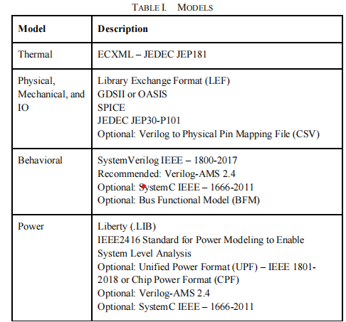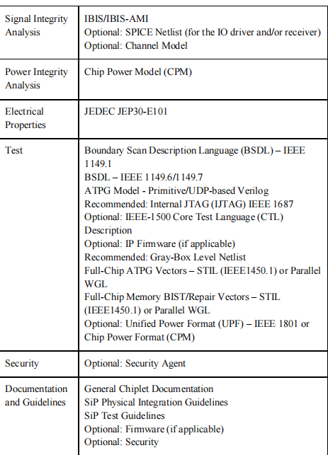
There are also some details shown in the paper when consider some parts of the model. For example. In electrical properties part, the paper propose using JEP30-E100 standard to capture the electrical and functional properties for a Chiplet part and its associated pins and ZEF is used to define mechanical, IO, and electrical information for packaged devices. Also the Github link is provided for the ZEF information https://github.com/zglue/zef.
The paper also show the present situation of the standard of the Chiplet model. ‘The newly proposed models will take some time to be formally adopted as standards, new standards and formats for 2.5D and 3D assembly rules also need to be developed, EDA vendors and 2.5D/3D manufacturers are collaborating on these new standards, with the hope that they will be officially implemented before the widespread adoption of the chiplet ecosystem.’

